***PAAREES PERFUMES***

***THIERRY MUGLER***

***FOR WOMEN***

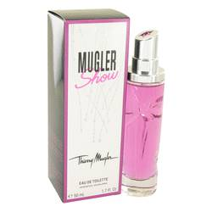

# 

***MUGLER SHOW***

## *Description:*

Mugler Show by Thierry Mugler Perfume. Mugler Show is deceptive in its simplicity, yet potent and enchanting because of the purity of the scent tones. A zesty and acidic opening of bergamot unfolds to a refreshing magnolia heart. Creamy white musk provides the base. The sweet and sour combination is the perfect choice for evening or daytime wear. The playful tanginess of the bergamot plays off the lightness and elegance of the magnolia for an effect that is utterly original and feminine, rather than overpowering. To experience the magic and seductiveness of Parisian nights, add this show stopping fragrance to your beauty essentials